Heart Disease Prediction Using Machine Learning

Project Overview
This project focuses on predicting heart disease using machine learning techniques based on patient health data. It includes data preprocessing, exploratory data analysis (EDA), feature scaling, model training, and performance evaluation. Multiple classification algorithms are compared using metrics such as accuracy, precision, recall, and F1-score to identify the best-performing model for heart disease prediction.
Dataset Size
The dataset consists of 303 rows and 14 columns, where each row represents a patient's record and each column represents a feature used for heart disease prediction.
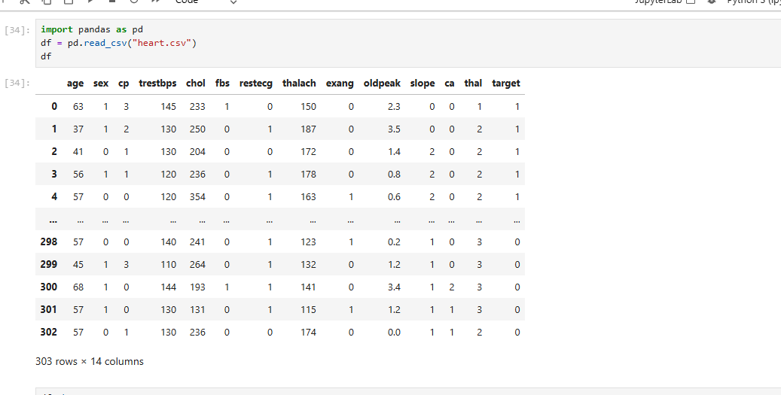
Feature Names
The dataset used in this project contains medical information related to patients and includes the following features:
- age - Age of the patient
- sex - Gender of the patient
- cp - Chest pain type
- trestbps - Resting blood pressure
- chol - Serum cholesterol level
- fbs - Fasting blood sugar
- restecg - Resting electrocardiographic results
- thalach - Maximum heart rate achieved
- exang - Exercise-induced angina
- oldpeak - ST depression induced by exercise
- slope - Slope of the peak exercise ST segment
- ca - Number of major vessels colored by fluoroscopy
- thal - Thalassemia
- target - Presence of heart disease (0 = No, 1 = Yes)
Among these features, target is considered the target variable because it represents the output that the model predicts.
Feature Datatypes
The dataset contains both numerical and categorical variables.
Numerical Features
The numerical features in the dataset are:
- Age
- Resting Blood Pressure (trestbps)
- Serum Cholesterol (chol)
- Maximum Heart Rate Achieved (thalach)
- ST Depression (oldpeak)
Categorical Features
The categorical features in the dataset are:
- Sex
- Chest Pain Type (cp)
- Fasting Blood Sugar (fbs)
- Resting Electrocardiographic Results (restecg)
- Exercise-Induced Angina (exang)
- Slope of Peak Exercise ST Segment (slope)
- Number of Major Vessels (ca)
- Thalassemia (thal)
- Target (Heart Disease: 0 = No Disease, 1 = Disease)

Null Value Analysis
Before building the Machine Learning model, the dataset was checked for missing values using the isnull() function.
The dataset doesn’t contain null values

Outlier Detection
Outliers are extreme observations that can negatively affect the performance of Machine Learning models.
Boxplots were used to identify outliers in all numerical columns.
The Interquartile Range (IQR) method was used to detect and handle outliers.

Box Plot
Boxplots were used to detect outliers in numerical variables.
Outlier Removal
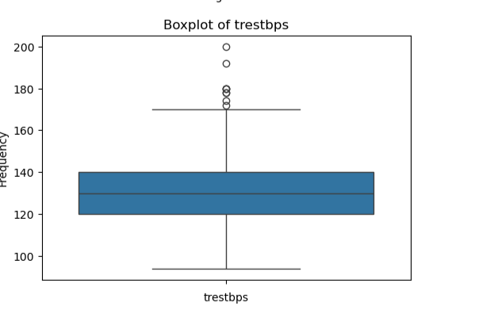
Outliers were identified and removed using the Interquartile Range (IQR) method. The numerical features Age, Resting Blood Pressure (trestbps), Serum Cholesterol (chol), Maximum Heart Rate (thalach), and ST Depression (oldpeak) were examined for outliers.
For each feature:
- The first quartile (Q1) and third quartile (Q3) were calculated.
- The Interquartile Range (IQR = Q3 − Q1) was computed.
- The lower and upper limits were determined as:
  - Lower Limit = Q1 − 1.5 × IQR
  - Upper Limit = Q3 + 1.5 × IQR
- Records with values outside these limits were removed from the dataset to reduce the effect of extreme values and improve model performance.
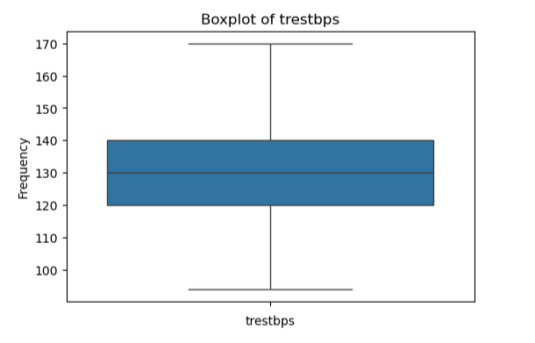

Loading the Dataset
The dataset was imported into Python using the Pandas library.
The dataset was loaded successfully using:

import pandas as pd
lifestyle = pd.read_csv("heart.csv")
After loading the dataset, the following checks were performed:
- View first few rows
- Dataset information
- Statistical summary
- Missing values
- Data types
Data Cleaning Process
Data cleaning is one of the most important steps in any Machine Learning project.
The following preprocessing steps were performed:
- Loaded the dataset
- Checked missing values
- Checked data types
- Separated numerical and categorical variables
- Checked duplicates
- Handled missing values
- Removed outliers using the IQR method

Encoding of Categorical Variables
Label Encoding was not performed because the categorical features in the Heart Disease dataset were already represented using numerical values. Therefore, the dataset was directly used for model training without any additional encoding.
These preprocessing techniques improved the quality of the dataset and made it suitable for Machine Learning algorithms.
Exploratory Data Analysis (EDA)
Exploratory Data Analysis was carried out to understand the dataset and identify meaningful relationships among variables.
The following visualizations were generated:
Histogram
Histograms were used to observe the distribution of numerical variables.
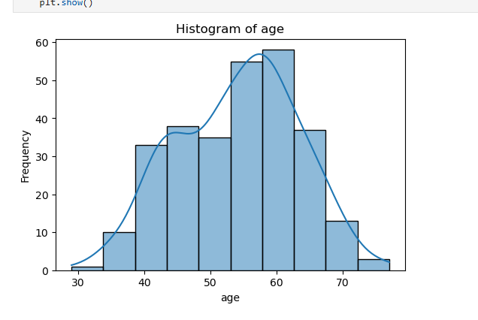

Scatter Plot
Scatter plots helped identify relationships between each independent variable and the target variable (Weight_Change).

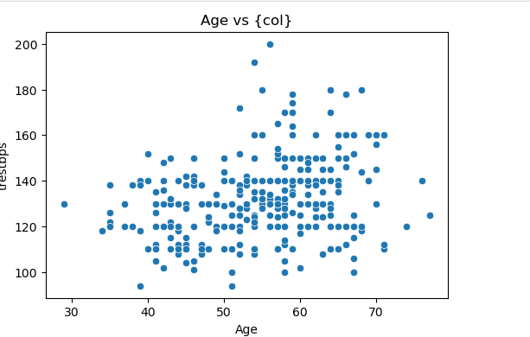
Correlation Heatmap
A heatmap was generated to study the correlation among all numerical features.
EDA helped in understanding the dataset structure and selecting relevant features for model building.
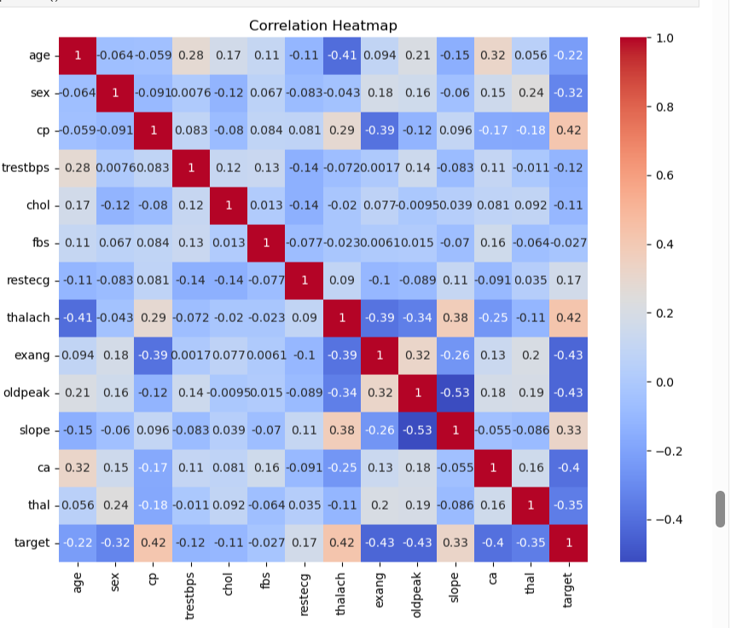
Feature Selection
Not all features contribute equally to predicting weight change.
The following features were selected for model training:
- CP
- thalach
- slope
- exang
- oldpeak
- ca
- thal
Reason for Feature Selection
The features cp, thalach, exang, oldpeak, ca, thal, and slope were selected based on their relatively strong correlation with the target variable. These features were expected to improve prediction performance. However, the model achieved similar accuracy compared to using only the top three features, indicating that cp, thalach, and slope alone capture most of the predictive information in the dataset.
Data Partition
The processed dataset was divided into training and testing datasets.
The split ratio used was:
- Training Dataset – 70%
- Testing Dataset – 30%
The split was performed using the train_test_split() function with a random state of 42 to ensure reproducibility.
The training dataset was used to train the model, while the testing dataset was used to evaluate its predictive performance.

Data Transformation
Machine Learning algorithms require properly formatted numerical input.
Two preprocessing techniques were applied.
Numerical Data
Numerical features were standardized using StandardScaler.
Standardization transforms all variables to have:
- Mean = 0
- Standard Deviation = 1
This improves model convergence and ensures that variables with larger ranges do not dominate the learning process.
Model Selection
Multiple machine learning classification models were trained and evaluated to identify the best-performing model for heart disease prediction. The following algorithms were used:
- Logistic Regression
- Decision Tree Classifier
- Random Forest Classifier
- Support Vector Machine (SVM)
- Gradient Boosting Classifier
- AdaBoost Classifier
Model Performance
The performance of all machine learning models was evaluated using Accuracy, Precision, Recall, and F1-Score. These metrics were used to measure the effectiveness of each model in predicting heart disease. The results of all models were compared, and the model with the highest performance was selected as the final model.
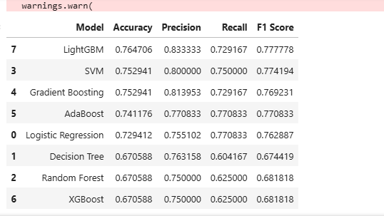
Best Performing Model
The LightGBM (LGBM) model achieved the best overall performance among all the evaluated models. Based on its evaluation metrics, it was selected as the final model for heart disease prediction..

Conclusion
This project applied various machine learning algorithms to predict heart disease. After preprocessing and evaluating multiple models, LightGBM (LGBM) achieved the best performance and was selected as the final model. The project demonstrates that machine learning can provide accurate and reliable predictions for early heart disease detection.

